ORDER NO. 21
of the Rector of the West Pomeranian University of Technology in Szczecin
of 10 February 2022
on the introduction of a Gender Equality Plan
for the West Pomeranian University of Technology in Szczecin
Pursuant to Article 23 of the Act of 20 July 2018 Law on Higher Education and Science (Journal of Laws of 2021, item 478, as amended), it is ordered as follows:
§ 1.
The Gender Equality Plan for the West Pomeranian University of Technology in Szczecin is introduced, which is annexed hereto.
§ 2.
The Order shall come into force on the day of adoption hereof.
Rector
dr hab. inż. Jacek Wróbel, prof. ZUT

Appendix to Resolution no. 21 of the Rector of the West Pomeranian University of Technology in Szczecin of 10 February 2022
Gender Equality Plan
for the West Pomeranian University of Technology in Szczecin
Table of contents
Introduction 6
1. Equality and discrimination at the West Pomeranian University of Technology in Szczecin - current status analysis 7
1.1. Gender structure at ZUT 7
Authorities of the West Pomeranian University of Technology in Szczecin 7
ZUT faculty authorities 8
Research councils 11
People employed at ZUT 16
Undergraduate students 23
Doctoral students 27
Postgraduate studies 31
Women in projects at ZUT 32
Summary of the analyses 33
1.2. Survey concerning equal treatment and discrimination 34
1.3. Selected actions for promotion equality and counteracting discrimination so far 34
DZ1. Implementation of principles and recommendations on the European Charter for Researchers and on a Code of Conduct for the Recruitment of Researchers 35
DZ2. Information for the employees concerning equal treatment in employment 35
DZ3. Support for persons with special needs, including persons with disabilities 35
DZ4. Taking account of gender aspect in recruitment campaigns 35
2. Objectives and action plan 34
2.1. Objective 1: Making the community of West Pomeranian University of Technology in Szczecin aware of discrimination and the principles of equal treatment. 34
D1.1. Creating a tab concerning the Plan implementation on the university Internet site 34
D1.2. Preparing the system of internal communication for students and teachers 34
D1.3. Drawing up and distributing a leaflet concerning discrimination for the academic community of ZUT 34
D1.4. Awareness trainings for the academic community of ZUT 34
2.2. Objective 2: pursuing to balance the gender composition in all groups of employees. 35
D2.1. Analysis of needs in respect of compensating gender representation in groups of employees 35
D2.2. Analysis of needs and formulating guidelines concerning taking account of compensating gender representation aspect in competition procedures 35
D2.3. Popularisation of taking account of gender representation compensation aspect in recruitment procedures 35
2.3. Objective 3: pursuing to balance the gender composition of students. 36
D3.1. Analysis of needs in respect of compensating gender equality in recruitment campaigns. 36
2.4. Objective 4: supporting the scientific career development of women. 37
D4.1. Making diagnosis of needs of female researchers employed at ZUT in respect of possibilities to support their career development and promotion. 37
D4.2. Formulating recommendations and suggestions in respect of activities for active support of women’s scientific careers. 37
2.5. Objective 5: counteracting all kinds of discrimination phenomena. 38
D5.1. Adopting and implementing the procedure of reporting and considering discrimination cases. Updating ani-mobbing procedures. 38
D5.2. Reviewing codes of ethics in force at ZUT and selected internal legal acts in view of the provisions concerning discrimination and equality. 38
D5.3. Diagnosis of main causes for discrimination experiences of persons who are not academic teachers and formulating recommendations for implementing more equality-oriented model of careers at those positions. 38
2.6. Summary of objectives and planned activities. 39
3. Implementation of the Equality Plan at the West Pomeranian University of Technology in Szczecin. 42
3.1. Administering of the Plan execution. 42
3.2. Monitoring, reporting, and communicating. 42
3.3. Verification and updating of the Plan. 42
3.4. Responsibility for the Plan’s execution. 42
List of figures 43
List of tables with data 44

Introduction

The main objective of the Gender Equality Plan for the West Pomeranian University of Technology in Szczecin, hereafter referred to as the "Plan", is to promote equality and diversity as those principles that affect the well-being of people working and studying at the University, to develop and fulfil their potential and increase their autonomy of thought and action. At the same time, they increase security, autonomy and fight against the objectification of the entire academic environment.

The adoption of this Plan complements and extends the range of pro-equality and anti-discrimination measures, implementing the commitments made by the University in connection with the award of the 'HR Excellence in Research' distinction by the European Commission.

It is also intended to implement the European Commission's recommendations on the implementation of the Gender Equality Plan in research units.

Irrespective of the fulfilment of the obligations incumbent on the University, the Plan is also intended to respond to the need for systematic action to counteract discrimination and promote equality, as indicated by the conclusions of research on the phenomenon of discrimination, including sexual harassment at Polish universities. The need for action in this area was also pointed out by the Minister of Science and Higher Education.

The Equality Plan is the result of the work of the Equality Commission at ZUT established by order of the Rector of the West Pomeranian University of Technology in Szczecin, prof. Jacek Wróbel, on 4 February 2022. The document was developed on the basis of an analysis of similar types of documents in force at Polish and European universities and based on the results of a diagnosis carried out at the University in the last quarter of 2021.

1. Equality and discrimination at the West Pomeranian University of Technology in Szczecin - current status analysis

1.1. Gender structure at ZUT
The first steps taken to diagnose the situation of women and men at the University involved the collection and analysis of figures related to the gender structure of employment in individual posts and units. The following summary is based on data collected in the fourth quarter of 2021.

Authorities of the West Pomeranian University of Technology in Szczecin
The function of the Rector of ZUT was held by a man during the period indicated, as were the functions of the Vice-Rectors: for Organisation and Development of the University, for Science, for Students' Affairs and for Education. The functions of the ZUT Bursar and Chancellor are held by women. There are currently seven members of the University Council, including two women. The figures are shown in Tab. 1. ZUT authorities and collegiate bodies from a gender perspective: as well as Fig. 1. ZUT authorities and collegiate bodies from a gender perspective. The Director of the ZUT Doctoral School is also a woman.
Tab. 1. ZUT authorities and collegiate bodies from a gender perspective
Individual columns in Tab. 1. ZUT authorities and collegiate bodies from a gender perspective:
- Women [%] - percentage of women in the Senate, University Council and University authorities in total;
- Men [%] - percentage of men in the Senate, University Council and University authorities in total;
- Women1 [%] - percentage of women in the ZUT authorities and collegiate bodies;
- Men1 [%] - percentage of men in the ZUT authorities and collegiate bodies.
- Figure/graph title - to be removed from the graph itself.
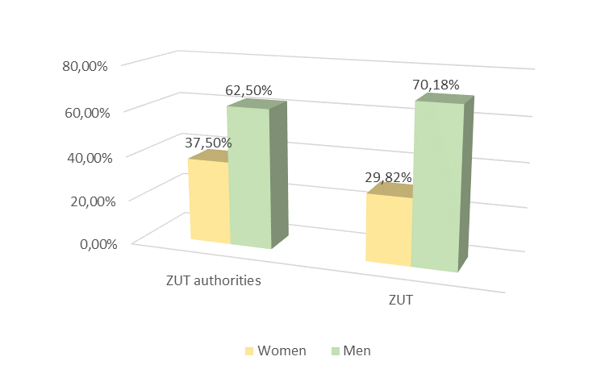
Fig. 1. ZUT authorities and collegiate bodies from a gender perspective

ZUT faculty authorities
Among faculty authorities at the West Pomeranian University of Technology in Szczecin, the ratio of women to men is currently close to balance (nearly 40% of women, approximately 60% of men). Of the 11 people serving as deans, 10 are men.
There is no clear link noted between the number of women and men employed in the faculties and the distribution of gender representation among the authorities of these units. At the faculty where the Dean's position is held by a woman, the gender ratio among the faculty authorities is also 3women to 1man. At one of the more feminised faculties, i.e. the Faculty of Chemical Technology and Engineering, the dean is a man while the faculty authorities are predominantly women. The Faculty of Electrical Engineering is managed entirely by men, while the Faculty of Computer Science and Information Technology as well as the Faculty of Mechanical Engineering and Mechatronics are managed predominantly by men. At the same time, these are faculties with a high degree of masculinisation, both among staff and students, which is largely due to the highly technical nature of these units.
The details in this regard are shown in Tab. 2. Representation of women and men in the ZUT faculty authorities by function.

Tab. 2. Representation of women and men in the ZUT faculty authorities by function.
Individual columns in Tab. 2. Representation of women and men in the ZUT faculty authorities by function.
- Women [%] - percentage of women in the ZUT faculty authorities;
- Men [%] - percentage of men in the ZUT faculty authorities.
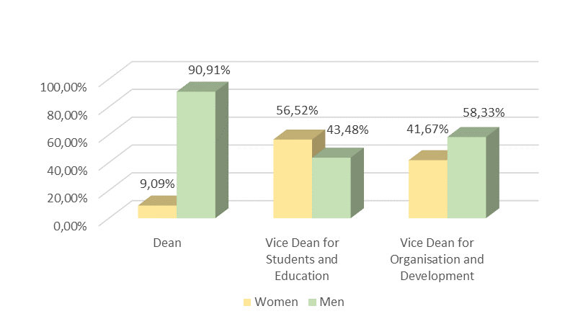
Fig. 2. Representation of women and men in the ZUT faculty authorities by function
In Tab. 3. Women and men in the faculty authorities - in general as well as in Fig. 3. Women and men in the faculty authorities - in general the following are shown:
- Women [%] - percentage of women in individual ZUT faculty authorities;
- Men [%] - percentage of men in individual ZUT faculty authorities.
Tab. 3. Women and men in the faculty authorities - in general.
 | ZUT faculty | Women | Men
ZUT faculties | Faculty of Architecture | 25% | 75%
ZUT faculties | Faculty of Biotechnology and Animal Husbandry | 50% | 50%
ZUT faculties | Faculty of Civil and Environmental Engineering | 75% | 25%
ZUT faculties | Faculty of Economics | 75% | 25%
ZUT faculties | Faculty of Electrical Engineering | 0% | 100%
ZUT faculties | Faculty of Computer Science and Information Technology | 20% | 80%
ZUT faculties | Faculty of Mechanical Engineering and Mechatronics | 20% | 80%
ZUT faculties | Faculty of Environmental Management and Agriculture | 50% | 50%
ZUT faculties | Faculty of Food Science and Fisheries | 25% | 75%
ZUT faculties | Faculty of Maritime Technology and Transport | 50% | 50%
ZUT faculties | Faculty of Chemical Technology and Engineering | 75% | 25%
 | Total | 42,27% | 57,73%

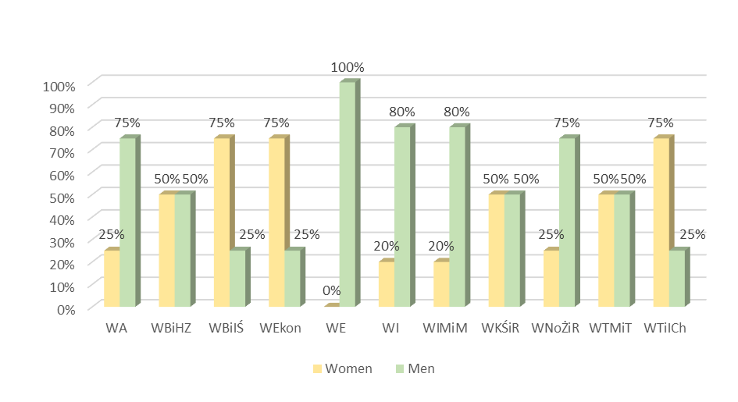
Fig. 3. Women and men in the faculty authorities - in general
The next set of data shows the share of women and men in the authorities of a given faculty in the populations of women and men, respectively, in the authorities of all ZUT faculties:
- Women [%] - percentage of women in individual ZUT faculty authorities in the population of women in the authorities of all faculties at ZUT;
- Men [%] - percentage of men in individual ZUT faculty authorities in the population of men in the authorities of all faculties at ZUT.
Tab. 4. Women and men in the ZUT faculty authorities from the perspective of the faculty authorities population
The following faculties (see Fig. 4 Women and men in the ZUT faculty authorities - the share in the faculty authorities population) are noteworthy: Faculty of Civil and Environmental Engineering (WBiIŚ), Faculty of Economics (WEkon) and Faculty of Chemical Technology and Engineering, where 75% of the faculty management team is made up of women (Figure 3. Women and men in faculty authorities - in general, thus representing a significant percentage (15.79%) despite not being the most numerous teams in terms of faculty authorities (see Tab. 2. Representation of women and men in the ZUT faculty authorities by function).
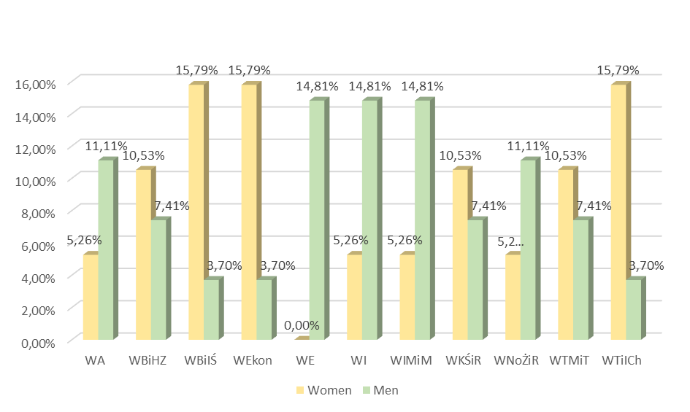
Fig. 4. Women and men in the ZUT faculty authorities - the share in the faculty authorities population
In Tab. 5. The proportion of women in management roles in the faculties, the columns denote:
- Women [%] - percentage of women in management roles in the population of the authorities of all faculties at ZUT;
- Men [%] - percentage of men in management roles in the population of the authorities of all faculties at ZUT.
Tab. 5. The proportion of women in management roles in the faculties
 | Management function | Women | Men
Function | Dean | 9,09% | 90,91%
Function | Vice Dean for Students and Education | 56,52% | 43,48%
Function | Vice Dean for Organisation and Development | 41,67% | 58,33%
 | Total | 35,76% | 64,24%

The figures in Tab. 5. The proportion of women in management roles at the faculties are shown in Fig. 2. Representation of women and men in the ZUT faculty.
The next subsection focuses on analysing of the composition of the research councils at ZUT.

Research councils
At the West Pomeranian University of Technology in Szczecin, 14 scientific disciplines are subject to evaluation. An equivalent number of research councils have thus been established, which are not collegiate bodies as of today.
Tab. 6. Representation of women and men in the research councils
The research councils are headed by the same number of women as men (Tab. 6. Representation of women and men in the research councils):
- Women [%] - total percentage of women in research councils;
- Men [%] - total percentage of men in research councils;
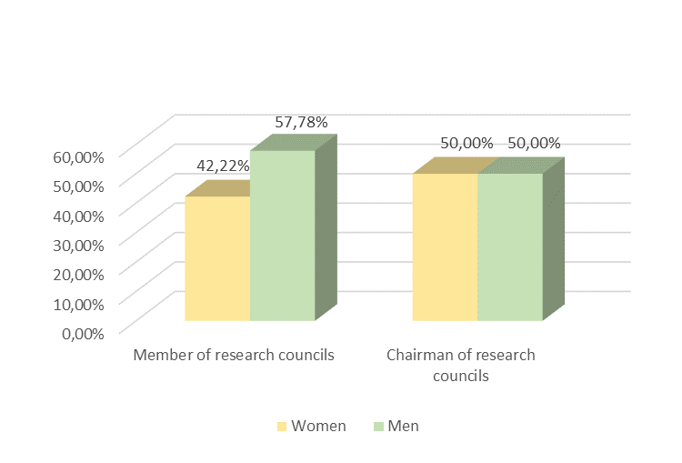
Fig. 5. Women and men in the research councils at ZUT
The proportion of women in research councils shows that at ZUT three research councils are typically male (Tab. 7. The ratio of the number of women and men in the research councils at ZUT). These are the following research councils:
- Automatic Control, Electronics and Electrical Engineering,
- Computer Engineering,
- Mechanical Engineering.
Research Councils with a clear majority of women are the councils representing the following disciplines:
- Materials Engineering,
- Chemical Sciences,
- Food Technology and Human Nutrition.
Tab. 7. The ratio of the number of women and men in the research councils at ZUT
Columns of Tab. 7. The ratio of the number of women and men in the research councils at ZUT denote the following:
- Women [%] - percentage of women in an individual research council;
- Men [%] - percentage of women in an individual research council;
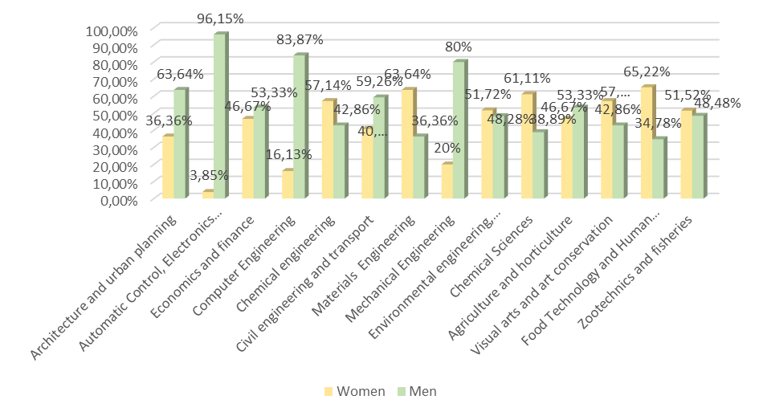
Fig. 6. Research councils at ZUT from gender perspective
Fig. 7. Research councils at ZUT from a gender perspective (synthesis) presents, in a synthetic manner, the results of an analysis of the current composition of the research councils at ZUT from a gender perspective. It is clear which councils are predominantly female and male.
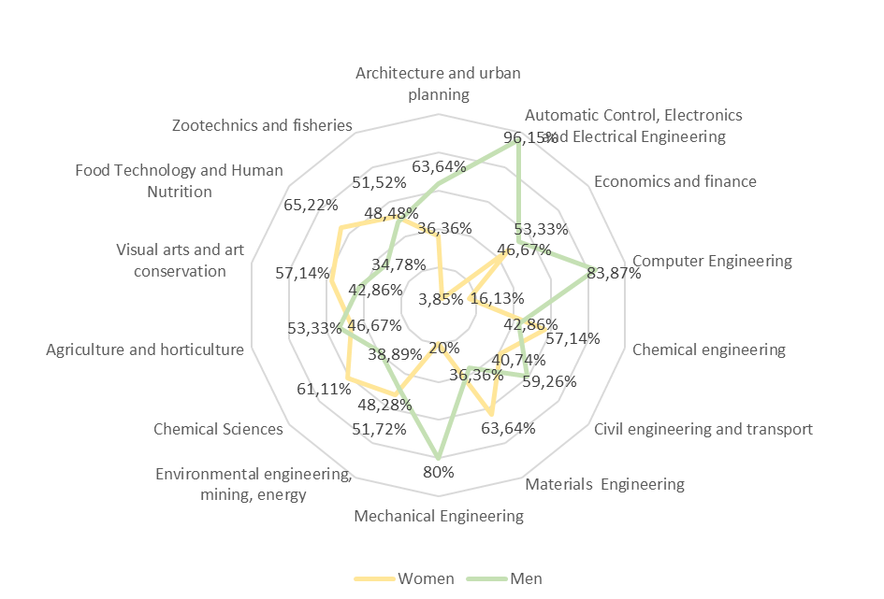
Fig. 7. Research councils at ZUT from gender perspective (synthesis)
Columns of Tab. 8. The ratio of women and men in research councils to all women and men - members of the research councils should be read as follows:
- Women [%] - percentage of women in individual ZUT faculty authorities in the population of women in all research councils at ZUT;
- Men [%] - percentage of women in individual ZUT faculty authorities in the population of men in all research councils at ZUT.
Tab. 8. The ratio of women and men in research councils to all women and men - members of the research councils.
The data on the composition of the research councils presented in this way confirm the conclusions presented at the beginning of the subsection.
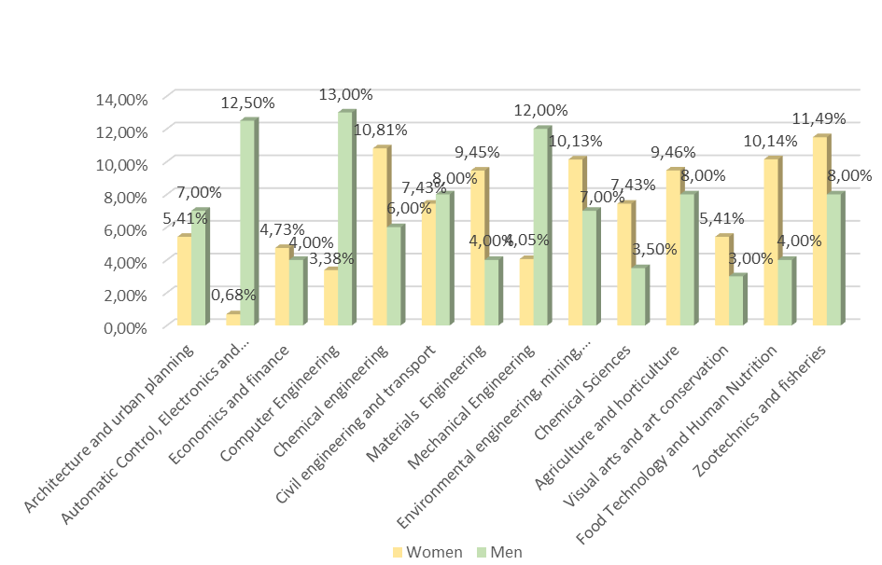
Fig. 8. The ratio of women and men in research councils to all women and men - members of the research councils
The research councils with a high ratio (this time in relation to the overall population of members of the research councils) include the research council of Chemical Engineering.
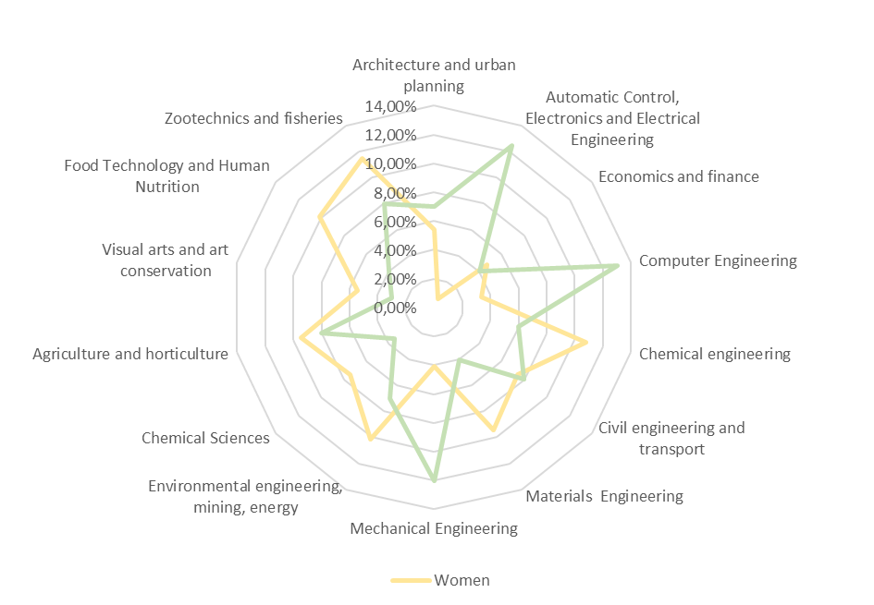
Fig. 9. The ratio of women and men in research councils to all women and men - members of the research councils
It can be concluded that, to a large extent, the proportion of women and men in research councils at ZUT is balanced, while, in terms of research council management - it is a model one - at 50%of women and 50%of men.

People employed at ZUT
Another area of analysis of ZUT from a gender perspective is employment in the job groups indicated in the title.
The percentage of women within the employee group in the total ZUT employee population is presented in Tab. 9. Employee groups in the ZUT employee population from a gender perspective and Tab. 10. Representation of women and men in the employee groups at ZUT:
- Women [%] - total percentage of women employed at ZUT;
- Men [%] - total percentage of men employed at ZUT;
- Women [%] - percentage of women of an individual employee group in the population of ZUT employees;
- Men [%] - percentage of women of an individual employee group in the population of ZUT employees.
Tab. 9. Employee groups in the ZUT employee population from a gender perspective
In total, of the 1,739 ZUT employees, women (1,020) account for nearly 60% of the workforce (Tab. 10. Representation of women and men in the employee groups at ZUT).
Tab. 10. Representation of women and men in the employee groups at ZUT
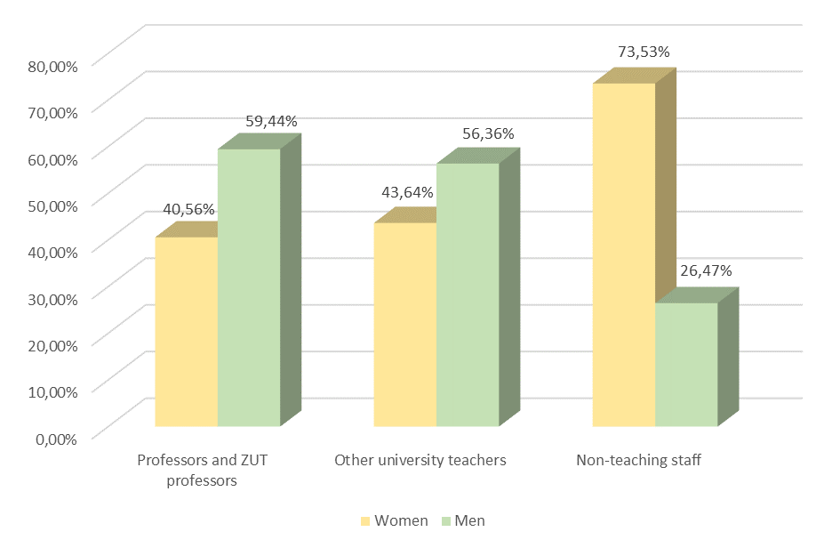
Fig. 10. Representation of women and men in the employee groups at ZUT from gender perspective
Analysis of the representation of women and men in individual ZUT units:
- Women [%] - percentage of women in an individual ZUT organisational unit;
- Men [%] - percentage of men in an individual ZUT organisational unit;
identifies three faculties (Faculty of Electrical Engineering, Faculty of Computer Science and Information Technology and Faculty of Mechanical Engineering and Mechatronics) as typically male in terms of average employment from a gender perspective.
Tab. 11. Women and men in individual ZUT units from a gender perspective
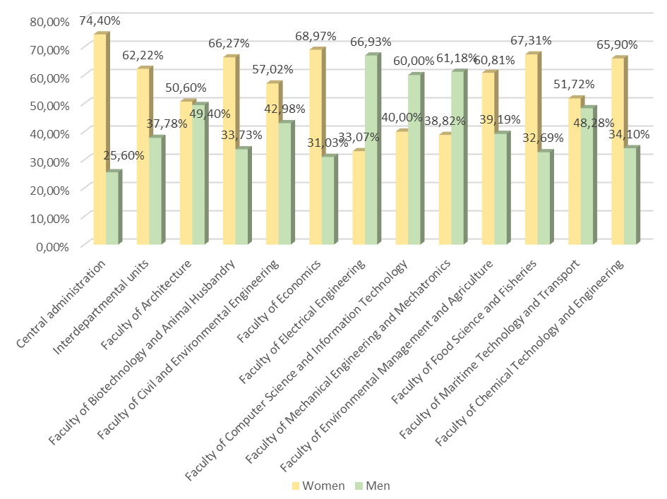
Fig. 11. Representation of women and men in individual ZUT units
Tab. 12. Women and men in individual units in relation to the total number of employees at ZUT presents the following:
- Women [%] - percentage of women of an organisational unit in the population of women in all organisational units at ZUT;
- Men [%] - percentage of men of an organisational unit in the population of men in all organisational units at ZUT.
The data is interesting in that it shows one faculty with a low number of female employees relative to the female employee population at ZUT (Faculty of Marine Technology and Transportation) and three faculties with a high number of male employees relative to the male employee population at ZUT (Faculty of Electrical Engineering, Faculty of Computer Science and Information Technology, Faculty of Mechanical Engineering and Mechatronics). The Faculty of Chemical Technology and Engineering, on the other hand, employs a significantly high number of women compared to the rest of the university.
The data will be commented on later in the subsection.
Tab. 12. Women and men in individual units in relation to the total number of employees at ZUT
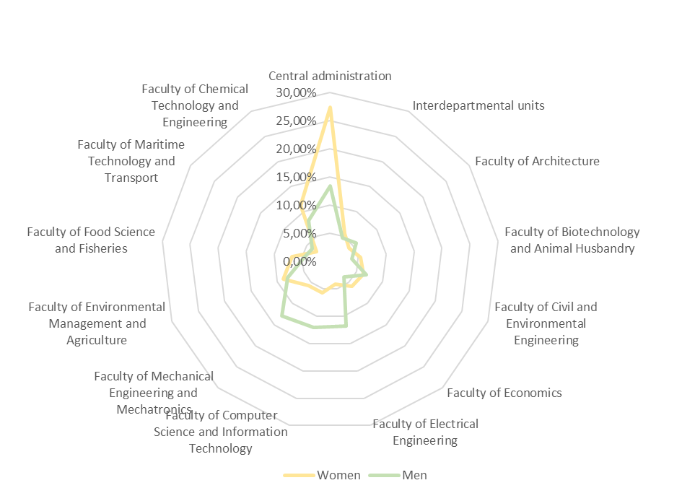
Fig. 12. Representation of women and men in individual units in relation to the total number of employees at ZUT
The columns of Tab. 13. Representation of women and men in the employee groups at ZUT within individual units includes the following data:
- Women [%] - percentage of women of an employee group in an individual ZUT organisational unit;
- Men [%] - percentage of men of an employee group in an individual ZUT organisational unit.
The data from the table above is shown in Figure 13. Representation of women and men by employee groups. Tab. 14. The employment structure of teachers at ZUT, in turn, presents detailed data on the employment structure of teachers at ZUT. The data make the discussion so far more detailed without significantly changing the theses and conclusions reached.
Tab. 13. Representation of women and men in the employee groups at ZUT within individual units
 | It is difficult to expect the employment of professors, university professors and other teachers in the central administration of ZUT. In the Interdepartmental Units, the gender share is fairly even.  What is noticeable, thanks to the Kj3 and Mj3 indicators, is the clear proportion of women in almost all faculties in the non-teaching staff group.  The Faculty of Biotechnology and Animal Husbandry (38.18% female faculty) is the only one with a high proportion of female staff who are among the university's professors and ordinary professors.  At the same faculty, the proportion of ordinary professors and university professors among men is also at a high level (53.57%).  At the faculties of: Electrical Engineering, Computer Science and Information Technology, Maritime Technology and Transport, there are the fewest female professors on average in the female populations (respectively: 2.38%, 1.72% and 6.67% - by numbers: 1, 1 and 2 - Tab. 10. Representation of women and men in the employee groups at ZUT).  Similarly, these faculties have the highest percentage of female non-teaching staff (after, of course, ZUT central administration).  This should not be attributed to any ill-will on the part of the faculty authorities - it is clearly due to the nature of the scientific disciplines practised in these faculties, which have not been popular among women in Poland for many years.
  Organisational unit | Employee group | Women | Men
  Central administration | Professors and ZUT professors | 0,00% | 0,00%
  Central administration | Other university teachers | 0,00% | 0,00%
  Central administration | Non-teaching staff | 100,00% | 100,00%
  Interdepartmental units | Professors and ZUT professors | 1,79% | 2,94%
  Interdepartmental units | Other university teachers | 69,64% | 73,53%
  Interdepartmental units | Non-teaching staff | 28,57% | 23,53%
  Faculty of Architecture | Professors and ZUT professors | 16,67% | 31,71%
  Faculty of Architecture | Other university teachers | 42,86% | 58,54%
  Faculty of Architecture | Non-teaching staff | 40,48% | 9,76%
  Faculty of Biotechnology and Animal Husbandry | Professors and ZUT professors | 38,18% | 53,57%
  Faculty of Biotechnology and Animal Husbandry | Other university teachers | 21,82% | 21,43%
  Faculty of Biotechnology and Animal Husbandry | Non-teaching staff | 40,00% | 25,00%
  Faculty of Civil and Environmental Engineering | Professors and ZUT professors | 12,31% | 14,29%
  Faculty of Civil and Environmental Engineering | Other university teachers | 33,85% | 65,31%
  Faculty of Civil and Environmental Engineering | Non-teaching staff | 53,85% | 20,41%
  Faculty of Economics | Professors and ZUT professors | 10,00% | 11,11%
  Faculty of Economics | Other university teachers | 46,67% | 66,67%
  Faculty of Economics | Non-teaching staff | 43,33% | 22,22%
  Faculty of Electrical Engineering | Professors and ZUT professors | 2,38% | 28,24%
  Faculty of Electrical Engineering | Other university teachers | 9,52% | 58,82%
  Faculty of Electrical Engineering | Non-teaching staff | 88,10% | 12,94%
  Faculty of Computer Science and Information Technology | Professors and ZUT professors | 1,72% | 20,69%
  Faculty of Computer Science and Information Technology | Other university teachers | 29,31% | 66,67%
  Faculty of Computer Science and Information Technology | Non-teaching staff | 68,97% | 12,64%
  Faculty of Mechanical Engineering and Mechatronics | Professors and ZUT professors | 10,17% | 27,96%
  Faculty of Mechanical Engineering and Mechatronics | Other university teachers | 37,29% | 46,24%
  Faculty of Mechanical Engineering and Mechatronics | Non-teaching staff | 52,54% | 25,81%
  Faculty of Environmental Management and Agriculture | Professors and ZUT professors | 21,11% | 37,93%
  Faculty of Environmental Management and Agriculture | Other university teachers | 20,00% | 29,31%
  Faculty of Environmental Management and Agriculture | Non-teaching staff | 58,89% | 32,76%
  Faculty of Food Science and Fisheries | Professors and ZUT professors | 21,43% | 29,41%
  Faculty of Food Science and Fisheries | Other university teachers | 34,29% | 29,41%
  Faculty of Food Science and Fisheries | Non-teaching staff | 44,29% | 41,18%
  Faculty of Maritime Technology and Transport | Professors and ZUT professors | 6,67% | 39,29%
  Faculty of Maritime Technology and Transport | Other university teachers | 23,33% | 32,14%
  Faculty of Maritime Technology and Transport | Non-teaching staff | 70,00% | 28,57%
  Faculty of Chemical Technology and Engineering | Professors and ZUT professors | 25,44% | 33,90%
  Faculty of Chemical Technology and Engineering | Other university teachers | 25,44% | 30,51%
  Faculty of Chemical Technology and Engineering | Non-teaching staff | 49,12% | 35,59%
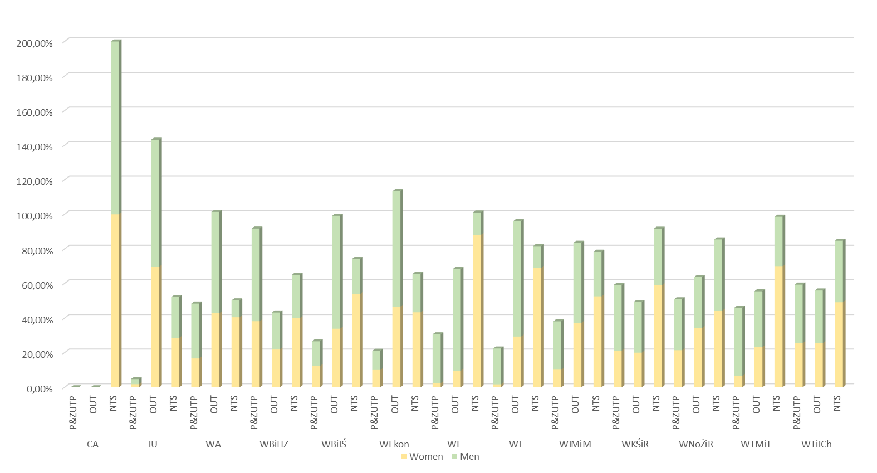
Fig. 13. Representation of women and men by employee groups
Tab. 14. Teacher employment structure at ZUT

Undergraduate students
Detailed data on the numbers of students at ZUT as at the date of this Plan are included in Tab. 15. Numbers of students studying at ZUT by the educational cycles and faculties providing education.
Tab. 15. Numbers of students studying at ZUT by the educational cycles and faculties providing education
The meaning of columns in Tab. 16. Numbers of students studying at ZUT by the educational cycles and Tab. 15. Numbers of students studying at ZUT by the educational cycles and faculties providing education:
- Women [%] - total percentage of female students at ZUT;
- Men [%] - total percentage of male students at ZUT;
- Women [%] - percentage of female students within a cycle of studies in the population of the female students of all faculties at ZUT;
- Men [%] - percentage of male students within a cycle of studies in the population of the male students of all faculties at ZUT.
Tab. 16. Numbers of students studying at ZUT by the educational cycles
At this level of generality, it can be concluded that there are, on average, almost twice as many women studying at ZUT as men.
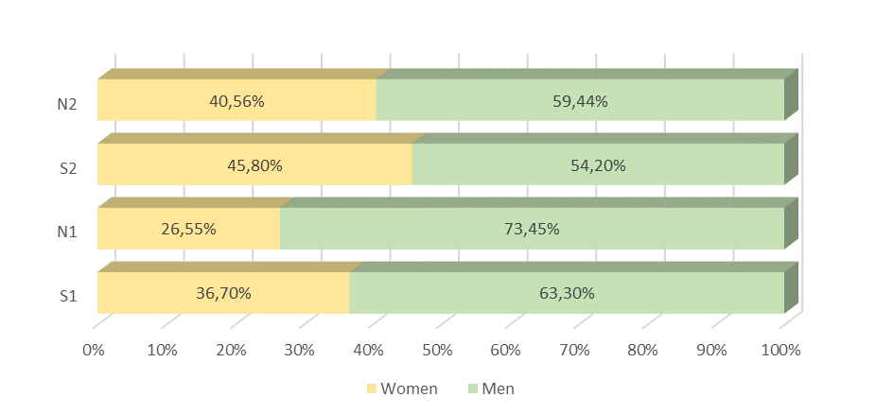
Fig. 14. The ratio of the representation of women and men among people studying at ZUT by the cycle of studies
Tab. 17. The proportion of women and men in the student populations of individual faculties at ZUT presents:
- Women [%] - percentage of female students at ZUT faculties, regardless of the cycle of studies;
- Men [%] - percentage of male students at ZUT faculties, regardless of the cycle of studies.
Tab. 17. The proportion of women and men in the student populations of individual faculties at ZUT
At the faculties of: Architecture, Biotechnology and Animal Husbandry, Economics as well as Food Sciences and Fisheries, there are noticeably more women studying. On the other hand, the faculties of: Electrical Engineering, Computer Studies and Information Technology, Mechanical Engineering and Mechatronics as well as Maritime Technology and Transport are faculties with a high proportion of male students.
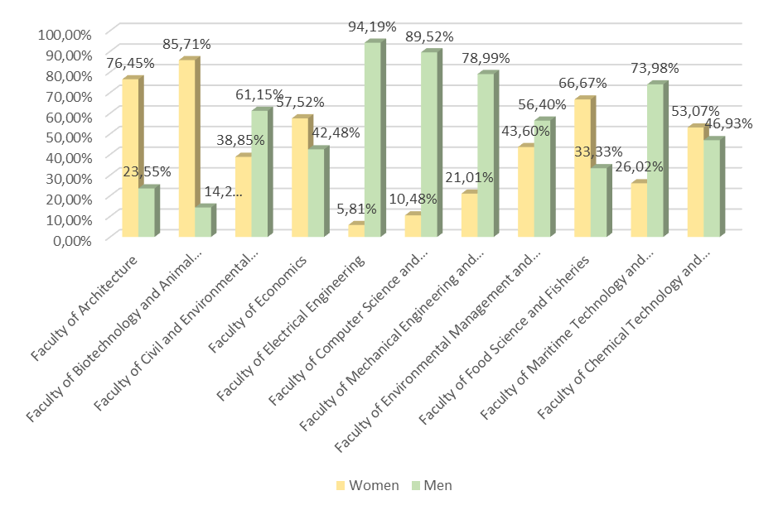
Fig. 15. The ratio of the representation of women and men among people studying at individual faculties
Among women studying at ZUT, most selected the following faculties: Faculty of Architecture, Faculty of Biotechnology and Animal Husbandry, Faculty of Civil and Environmental Engineering, whereas men mostly (the men studying at ZUT) selected the following faculties: Faculty of Computer Studies and Information Technology, Faculty of Mechanical Engineering and Mechatronics as well as Faculty of Civil and Environmental Engineering.
Tab. 18. Women and men studying at individual faculties from the perspective of the population of women and men studying at ZUT
 | ZUT faculty | Women | Men
ZUT faculties | Faculty of Architecture | 16,92% | 2,96%
ZUT faculties | Faculty of Biotechnology and Animal Husbandry | 16,46% | 1,56%
ZUT faculties | Faculty of Civil and Environmental Engineering | 16,42% | 14,67%
ZUT faculties | Faculty of Economics | 11,02% | 4,62%
ZUT faculties | Faculty of Electrical Engineering | 2,06% | 18,93%
ZUT faculties | Faculty of Computer Science and Information Technology | 4,98% | 24,18%
ZUT faculties | Faculty of Mechanical Engineering and Mechatronics | 7,59% | 16,20%
ZUT faculties | Faculty of Environmental Management and Agriculture | 8,09% | 5,95%
ZUT faculties | Faculty of Food Science and Fisheries | 7,13% | 2,03%
ZUT faculties | Faculty of Maritime Technology and Transport | 3,80% | 6,13%
ZUT faculties | Faculty of Chemical Technology and Engineering | 5,53% | 2,78%
 | Total | 100,00% | 100,00%

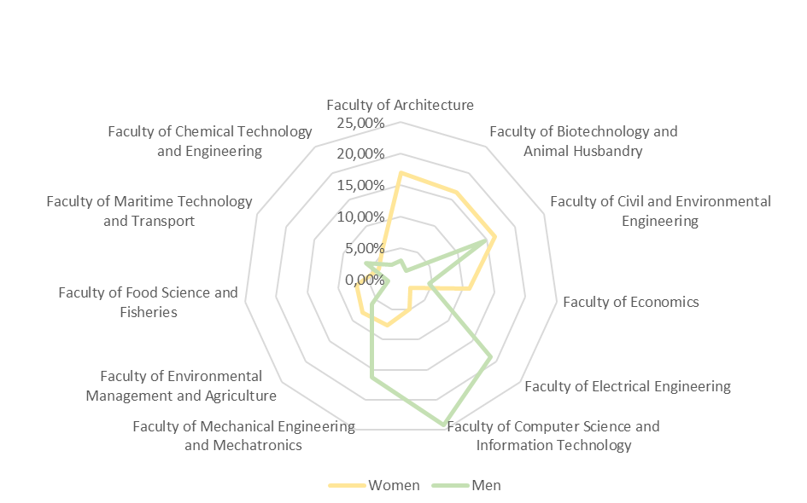
Fig. 16. Representation of women and men studying at individual faculties in relation to the total number of students at ZUT
Columns of Tab. 18. Women and men studying at individual faculties from the perspective of the population of women and men studying at ZUT denote the following:
- Women [%] - percentage of female students at the faculties in the population of female students at all ZUT faculties;
- Men [%] - percentage of male students at the faculties in the population of male students at all ZUT faculties;

Tab. 19. Percentage of female and male students by faculty within individual cycles of studies
 | At most ZUT faculties, the proportion of female students at S1 level in relation to all female students at the faculties is between 70 and 76%. All women studying in the S2/N2 cycle account for nearly 30% of women studying at the faculty, at the following faculties: Faculty of Architecture, Faculty of Civil and Environmental Engineering as well as Faculty of Mechanical Engineering and Mechatronics.  In the case of men, the percentage of S2/N2 cycle students in relation to all male faculty students reaches 30% only at the Faculty of Architecture and 26% at the Faculty of Chemical Technology and Engineering.  This indicates a greater determination, relative to female students in general, to complete a two cycles of studies.  The meaning of columns:  - Women [%] - percentage of female students within a cycle of studies at an individual ZUT faculty;  - Men [%] - percentage of male students within a cycle of studies at an individual ZUT faculty.
   | Cycle of studies | Women | Men
  WA | S1 | 75,68% | 67,54%
  WA | N1 | 0,00% | 0,00%
  WA | S2 | 21,35% | 29,82%
  WA | N2 | 2,97% | 2,63%
  WBiHZ | S1 | 77,50% | 78,33%
  WBiHZ | N1 | 16,11% | 13,33%
  WBiHZ | S2 | 0,00% | 0,00%
  WBiHZ | N2 | 6,39% | 8,33%
  WBiIŚ | S1 | 54,60% | 49,91%
  WBiIŚ | N1 | 15,60% | 26,55%
  WBiIŚ | S2 | 5,57% | 7,61%
  WBiIŚ | N2 | 24,23% | 15,93%
  Wekon | S1 | 68,05% | 76,97%
  Wekon | N1 | 19,09% | 14,61%
  Wekon | S2 | 12,86% | 8,43%
  Wekon | N2 | 0,00% | 0,00%
  WE | S1 | 71,11% | 68,31%
  WE | N1 | 6,67% | 16,05%
  WE | S2 | 13,33% | 6,31%
  WE | N2 | 8,89% | 9,33%
  WI | S1 | 71,56% | 75,08%
  WI | N1 | 19,27% | 16,33%
  WI | S2 | 9,17% | 5,91%
  WI | N2 | 0,00% | 2,69%
  WIMiM | S1 | 50,00% | 59,13%
  WIMiM | N1 | 20,48% | 27,56%
  WIMiM | S2 | 8,43% | 3,85%
  WIMiM | N2 | 21,08% | 9,46%
  WKŚiR | S1 | 67,23% | 70,31%
  WKŚiR | N1 | 14,69% | 21,83%
  WKŚiR | S2 | 11,30% | 5,68%
  WKŚiR | N2 | 6,78% | 2,18%
  WNoŻiR | S1 | 76,92% | 97,44%
  WNoŻiR | N1 | 0,00% | 0,00%
  WNoŻiR | S2 | 21,79% | 2,56%
  WNoŻiR | N2 | 1,28% | 0,00%
  WTMiT | S1 | 95,18% | 89,83%
  WTMiT | N1 | 0,00% | 0,00%
  WTMiT | S2 | 4,82% | 10,17%
  WTMiT | N2 | 0,00% | 0,00%
  WTiICh | S1 | 81,82% | 73,83%
  WTiICh | N1 | 0,00% | 0,00%
  WTiICh | S2 | 18,18% | 26,17%
  WTiICh | N2 | 0,00% | 0,00%

Doctoral students
The Doctoral School is currently being run at ZUT. A total of 40 women and 48 men are conducting their studies in eleven scientific disciplines.

Tab. 20. Data on women and men by organisational units
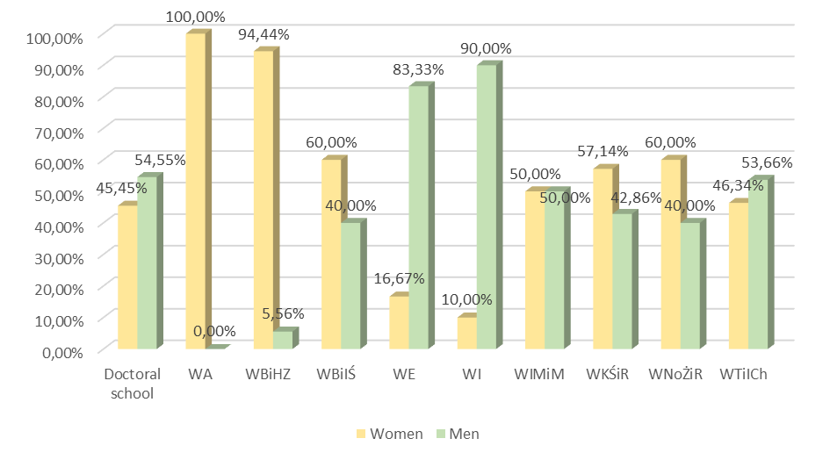
Fig. 17. Representation of women and men among doctoral students by ZUT units
Tab. 20. Data on women and men by organisational units contains information on women and men studying at ZUT in the third cycle by ZUT units:
- Women [%] - percentage of female doctoral students at ZUT;
- Men [%] - percentage of male doctoral students at ZUT.
Division into scientific disciplines is the subject of data in Tab. 21. Women and men pursuing PhDs in scientific disciplines:
- Female - share of female doctoral students in scientific disciplines at ZUT (also percentage Women [%]);
- Male - share of male doctoral students in scientific disciplines at ZUT (also percentage Men [%]);

Tab. 21. Women and men pursuing PhDs in scientific discipline
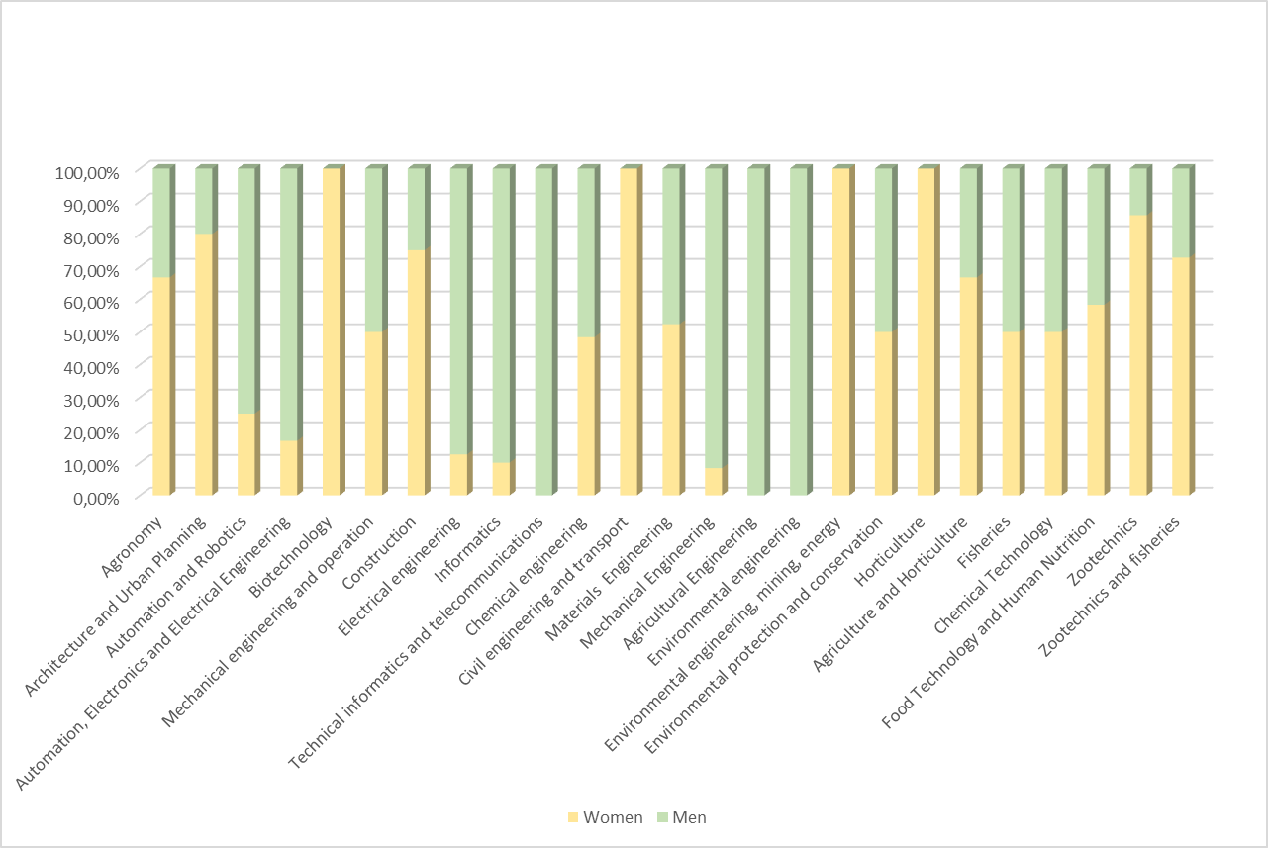
Fig. 18. Ratio of female to male representation among doctoral students in all scientific disciplines at ZUT
The last set of data in this subsection concerns the ZUT scientific disciplines chosen by women and men (as at 04.02.2022 ):
- Kdr2 [%] - percentage of female doctoral students in the population of female doctoral students in all scientific disciplines;
- Mdr2 [%] - percentage of male doctoral students in the population of male doctoral students in all scientific disciplines.

Tab. 22. Women and men working on doctoral theses by disciplines
The scientific disciplines chosen by the majority of female doctoral students at ZUT include:
- Chemical Technology,
- Chemical Engineering,
- Biotechnology,
- Materials Engineering,
The scientific disciplines mostly chosen by male doctoral students at ZUT include:
- Chemical Technology,
- Chemical Engineering,
- Mechanical Engineering,
- Materials Engineering,
- Computer Science and Information Technology.
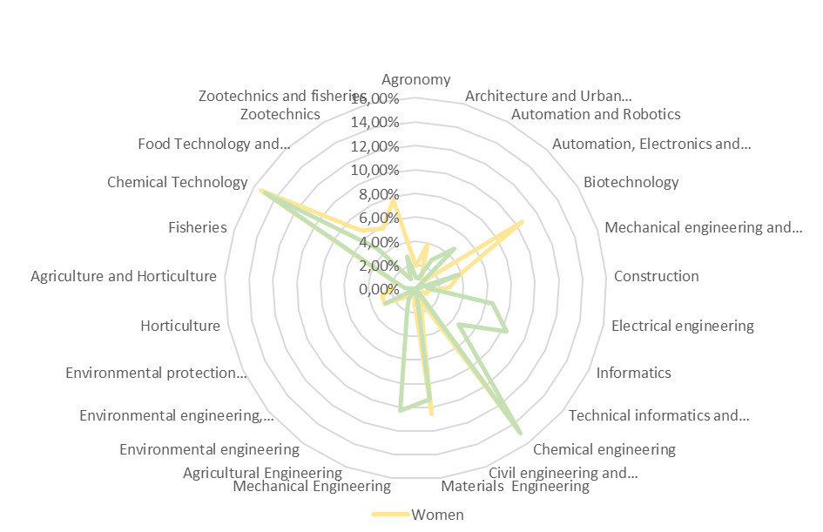
Fig. 19. Representation of female and male doctoral students in all disciplines at ZUT (synthesis)

Postgraduate studies
A total of 12 different postgraduate programmes are being run at six faculties of ZUT. Half of these have a preponderance of female participants, although not as much as the other six. Individual columns in Tab. 23. Participants of postgraduate studies at ZUT from gender perspective:
- Women [%] - percentage of women among participants of postgraduate studies at ZUT;
- Men [%] - percentage of men among participants of postgraduate studies at ZUT.

Tab. 23. Participants of postgraduate studies at ZUT from gender perspective
Five of the twelve postgraduate courses offered at ZUT are aimed explicitly at men. The others have clearly gender-independent addressees.
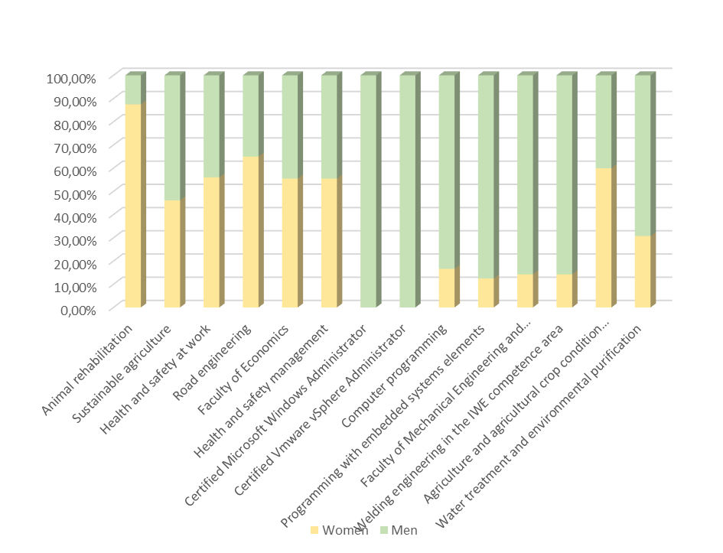
Fig. 20. Women and men - participants in postgraduate studies at ZUT

Women in projects at ZUT
The percentage of women and men carrying out tasks for externally funded projects is the subject of the last analysis.
Tab. 24. Share of women and men in projects conducted at ZUT.
It is difficult to find any regularity in this data - women at ZUT generally manage a similar number of projects as men.
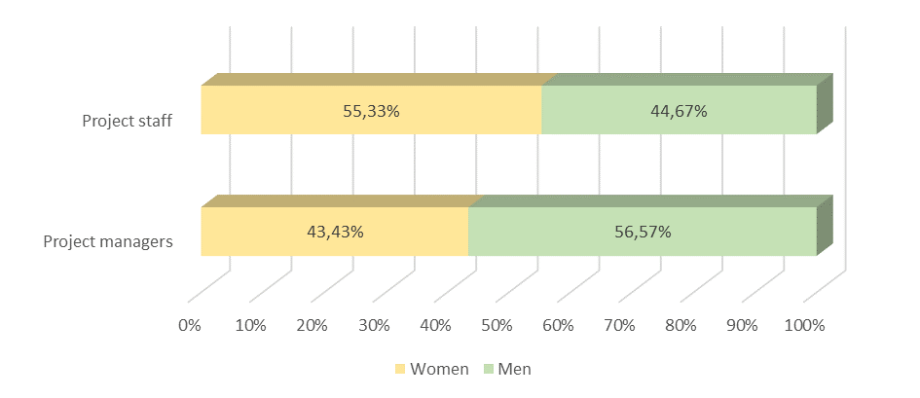
Fig. 21. Share of women and men in projects conducted at ZUT
Similarly, the participation of women in projects at ZUT is at a similar level to that of men. No relation to gender shall be found in this area, but rather a relation to the experience and capacity of the teams raising project funding.

Summary of the analyses
In terms of data quality, the analyses presented in the Plan can be divided into two groups:
- information of a static nature that does not change frequently (faculty boards, composition of discipline councils, collegiate bodies of the university such as the Senate, staff composition of the university),
- information of a dynamic nature - numbers of female students, doctoral students (lesser dynamics of changes).
It thus seems advisable to develop procedures and tools that will make it possible in the future to analyse, on an ongoing basis, the data presented in this Plan with regard to gender participation in the groups defined here.

1.2. Survey concerning equal treatment and discrimination
A survey concerning equal treatment and discrimination will be conducted at West Pomeranian University of Technology in Szczecin in 2022 as part of the implementation of the HR management strategy.
At present, a survey resulting from HR Excellence in Research distinction has been conducted. 646 full replies were collected in the survey, 284 from women and 362 from men.
According to the respondent, no signs of discrimination are notices at ZUT, including gender discrimination.
Tab. 25. Selected issues of the survey relating to gender equality
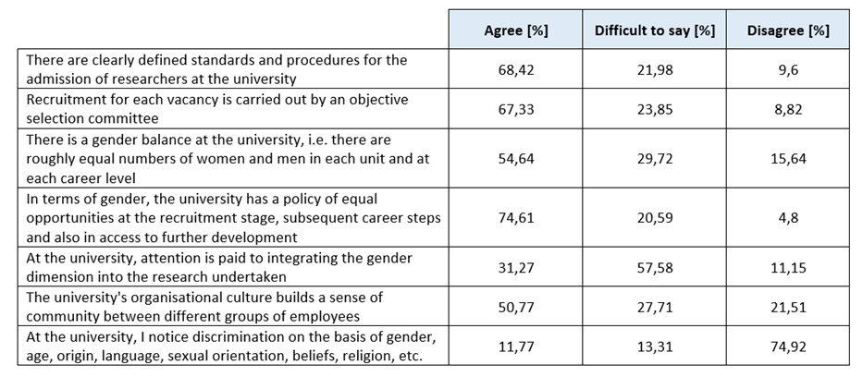

1.3. Selected actions for promotion equality and counteracting discrimination so far
The following is the presentation of the activities taken at ZUT in counteracting discrimination and preventing broadly understood exclusion.

DZ1. Implementation of principles and recommendations on the European Charter for Researchers and on a Code of Conduct for the Recruitment of Researchers
The European Charter for Researchers and on a Code of Conduct for the Recruitment of Researchers are one of the most important documents of the European policy for improving the attractiveness of work conditions and development of researchers careers in Europe. The West Pomeranian University of Technology in Szczecin, as a university that observes the principles of the Charter and the Code, is obligated to behave responsibly, in a manner that recognises dignity of humans and life.
Adapting to the recommendations collected in the Charter and the Code, the Code of Ethics of an Academic Teacher (Order no. 148 of the Rector of ZUT dated 5 October 2020) was prepared and issued at the West Pomeranian University of Technology.
The Code of Ethics of an Academic Teacher presents the most important ethical standards and values, as well as the principles of conduct and obligations of an academic teacher that guarantee observing such ethical values as equal treatment of all people, in particular with a view to the development of an attractive, open, and balanced European work market for researchers.

DZ2. Information for the employees concerning equal treatment in employment
Circular no. 7 of the Rector of the West Pomeranian University of Technology in Szczecin dated 13 April 2021 on the Procedure of Job Recruitment and Professional Development of the Employees of the West Pomeranian University of Technology in Szczecin was issued in 2021. The procedure was implemented as part of activities resulting from holding „HR Excellence in Research” distinction, which obligated the university to take actions called the Employment Guide Including Good Academic Practise in this Respect.
The Guide was supposed to determine the principles of recruitment, employment, and other issues at various stages of the employees’ career, also in order to considerably improve the employment conditions by honest, open, effective, and transparent recruitment procedure at the university.

DZ3. Support for persons with special needs, including persons with disabilities
Architectural, digital, informational, and communicational accessibility is being successively increased at ZUT. At present, there are two paths of securing the needs of persons with special needs, including persons with disabilities (PwD).
The first path includes current tasks relating to adapting of the recruitment and learning process and is executed by the Plenipotentiary for Student with Disabilities in co-operation with Vice Rector for Education. Pierwsza ścieżka obejmuje bieżące zadania związane z dostosowaniem procesu rekrutacji i kształcenia realizowane są przez Pełnomocnika ds. studentów i doktorantów z niepełnosprawnościami we współpracy w Prorektorem ds. kształcenia. In recent years the activities included:
- at requests of deans and heads of interfaculty units, didactic rooms have been equipped with high-resolution multimedia projectors, computers with touchscreens, or laboratory tables for persons on wheelchairs;
- equipment for the Office for Support of Persons with Disabilities (BON) used for adapting didactic materials has been purchased: e.g., PIAF heaters, Braille label machine, electronic magnifying glass, scanning and reading device, as well as tactile walking surface indicators have been installed and Braille plates have been bought to be installed in the building where the office is located;
- fitting Dean’s Offices and receptions with induction loops to support hearing of persons with hearing disfunction has been started;
- the first batch of evacuation chairs for safe evacuation of persons with moving problems has been purchased. As part of current actions, teaching assistants of students who need this kind of suport are being employed, and specialist trainings for teachers to increase competence in supporting PwDs are financed.
- open online workshop „A Student in Pandemic - Awareness of Defence Mechanisms in a Pandemic Situation” for ZUT community (students, doctoral students, employees) has been organised.
The second path was executed from 1 January 2020 to 30 June 2023 as part of a project called „Eliminating barriers in access to education - perfectly adapted” (POWR.03.05.00-00-A050/19-00), the purpose of which is to increase accessibility of the university for persons with disabilities by organisational changes, improving the awareness of ZUT managerial, administration, and academic staff in rational adaptation to the needs of persons with various disabilities. The project included:
- the Office for Persons with Disabilities was established, a person with disabaility as the administrative Staff and a psychologist was employed;
- a team for accessibility to education was formed, which consists of representatives of academic teachers, administrative Staff, whose task is to monitor and submit rational ideas concerning eliminating barriers in the academic space; creating and updating procedures and standards concerning functioning of BON, recruitment, education, accessibility for persons with special needs, a catalogue of possible support, etc.; and reviewing and initiating adapting legal acts of the university to the needs of persons with special needs, including persons with disabilities;
- thanks to the activities of the consultant for digital accessibility and her assistant (employees of the University Information Technology Centre), the accessibility of the Internet sites was increased, the effect of which is a considerable increase in the accessibility of the university sites to persons with sight disfunctions. In May 2021, the university sites were assessed as the best in the Report on Digital Accessibility of Universities in Poland;
- a series of trainings will be conducted with the purpose of increasing competence of the didactic and administrative staff in support for persons with disabilities. Awareness trainings are planned, including more than 450 academic teachers and 90 administrative Staff, and additionally specialist training in the support of persons with sight disfunctions, hearing disfunctions, and with mental disorders, as well as the Polish Sign Language trainings for at least 15 persons.
ZUT has an increasing awareness of the needs of persons with special needs and constantly wants to improve in this respect, the proof of which are consecutive projects concerning broadly understood accessibility and support for persons with disabilities, i.e., “Accessible Space Shaping Academy” (POWR.03.05.00-00-PU13/19-00) and a partnership project with Szczecin University called “University Centre of Accessibility Knowledge” (POWR.03.05.00-00-CW03/20-00).

DZ4. Taking account of gender aspect in recruitment campaigns
The employees of the Students Section and the members of the Faculty Recruitment Committees who recruit candidates to study, care for all candidates with the same involvement, regardless their gender, citizenship, or other aspects. The principles of the recruitment resolution ensure just treatment of candidates, and examinations checking candidates’ talents organised for artistic programmes of studies are conducted using coding of works. We encourage female candidates to study at masculinised faculties, e.g., by „Girls to Technical Universities” action, but apart from advising candidates, we cannot interfere with their individual preferences concerning the choice of a programme of studies.
The university crates favourable conditions for candidates with disabilities, in particular for those who have artistic skills test or interview. A candidate with disability, before they start their recruitment procedure, contacts BON in a convenient form in order to agree on a type of support during the recruitment process and to establish a candidate’s needs at a chosen programme of studies. There is a possibility to adapt the conditions and the form of the examination to the needs of a candidate with disability, for instance by prolonging the examination duration, adapting the font size, using technical facilities, using an assistant.
We can observe every year an increaing number of female candidates in relations to the general number of candidates at ZUT. When analysing the statistical data concerning the university structure, we should notice the fact that the most feminised faculties at the university are: the Faculty of Biotechnology and Animal Husbandry (85,71% of women), Faculty of Architecture (76,45%), and Faculty of Food Sciences and Fisheries (66,67%), the least per cent of female students are at the Faculty of Computer Science and Information technology and Faculty of Maritime Technology and Transport.
2. Objectives and action plan

2.1. Objective 1: Making the community of West Pomeranian University of Technology in Szczecin aware of discrimination and the principles of equal treatment.
The objectives of the Gender Equality Plan for ZUT were drawn up basing on the meetings with the representatives of the authorities, administrative units, university committees. Six basic objectives were accepted to implementation:
- increasing awareness of the community of the West Pomeranian University of Technology in Szczecin of discrimination and the principles of equal treatment,
- pursuing to balance the gender composition in all groups of employees,
- pursuing to balance the gender composition of students,
- supporting the scientific career development of women,
- counteracting all kinds of discrimination phenomena,
- making the researchers and students of ZUT aware of taking account of gender aspect in scientific research.

D1.1. Creating a tab concerning the Plan implementation on the university Internet site
Starting and updating the „Equal and Transparent at ZUT” Internet site to popularise equality attitudes and counteract discrimination among the students and employees.

D1.2. Preparing the system of internal communication for students and teachers
Transmitting the information concerning anti-discrimination procedures and the principles of equal treatment via internal e-mails to the whole academic community.
It is planned as part of internal communication to create a network of contacts administered in co-operation with the Plenipotentiary for Equal Treatment using ZUT e-mails and other social networks. The dedicated e-mail address rownizut@zut.edu.pl was created to facilitate the communication.

D1.3. Drawing up and distributing a leaflet concerning discrimination for the academic community of ZUT
Drawing up a leaflet (traditional, electronic, poster) containing basic information defining the forms of discrimination with the procedure of reporting violations.
Leaflets in a form of a poster should be placed in places accessible to the whole academic community, such as Dean’s Offices, International Mobility Department, student hostels, HR Department. An electronic leaflet (a banner) should be permanently placed in a visible place on the university’s site.

D1.4. Awareness trainings for the academic community of ZUT
Online trainings are planned dedicated to the whole academic community of ZUT about counteracting mobbing and discrimination. The aim of the trainings will be to increase the knowledge of discrimination, violence, and harassment, which will increase the ability to recognise the phenomena and to react in an appropriate way.
2.2. Objective 2: pursuing to balance the gender composition in all groups of employees.
The West Pomerania University of Technology in Szczecin takes actions aiming at balancing the gender structure in all groups of employees and at all levels of employment at the university pursuing to reach the gender equality. The numbers indicated in the first part present the employment structure at individual posts and in individual units according to gender. Attaining gender equality should be treated as a long-term objective without the deadline for execution. The first activity is to apply equality in the recruitment process. All employees and candidates for work participating in the recruitment process must have equal rights concerning identical responsibilities. The conditions for employment should be competence and experience. It should be noted that there are situations in which differentiation of the employees’ situation is legally justified and is not treated as a violation of the principles of equal treatment, therefore each case requires an in-depth analysis. The West Pomeranian University of Technology in Szczecin takes compensatory measures, which are legally allowed method to prevent discrimination conditioned by gender and strengthening equal chances of women and men.

D2.1. Analysis of needs in respect of compensating gender representation in groups of employees
The analysis of compensating gender representation in groups of employees and preparing the guidelines for the principles of appointing persons to managerial positions at the West Pomeranian University of Technology in Szczecin, taking into account compensating gender representation in the university authorities, competition committees, and various units and expert and review commissions, enables indicating the guidelines in the internal regulations of ZUT until the end of the year 2023.

D2.2. Analysis of needs and formulating guidelines concerning taking account of compensating gender representation aspect in competition procedures
The West Pomeranian University of Technology in Szczecin undertakes to prepare solutions concerning taking account of compensating gender representation in competition procedure. All kinds of advertisements concerning competitions for research, research-didactic, and didactic positions should include gender equality. The guidelines in this respect should be prepared and communicated to the university units to the end of 2022.

D2.3. Popularisation of taking account of gender representation compensation aspect in recruitment procedures
The West Pomeranian University of Technology in Szczecin undertakes to pay special attention to the fact that the message of recruitment campaigns should include the aspect of compensating gender representation of persons applying to become a ZUT student. Promotional materials should encourage women to study at faculties with the majority of men and to encourage men to study at faculties with the female majority. Apart from its own promotion campaign, ZUT will involve in the activities of other entities that promote the action „Girls to Technical Universities”.
2.3. Objective 3: pursuing to balance the gender composition of students.
Direct promotional and informational activities that are part of the agenda are meetings with secondary-school graduates and students in their schools, at education fairs, open air events, and open days. The meetings are planned to stress to encourage women to study university programmes where they are in minority. The encouragement will consist in indicating the achievements of our female students and teachers, as well as showing examples of women in business who were successful in Poland and internationally after graduating from technical universities. We will try to invite in particular ZUT female students to co-operate in presenting the university’s offer during open-air events.
Indirect activities will be based on:
- the execution of projects devoted to women in which gender parity in employing in the projects execution will be applied;
- advertising such as: radio spots, internet banners, social media advertising, where a presented image on photos or in audio information is always selected in such a manner that there is a male and a female.

D3.1. Analysis of needs in respect of compensating gender equality in recruitment campaigns.
Analysis of this kind have so far been made for the needs of recruitment processes for projects financed from the funds of the Operational Programme Human Capital and Operational Programme Knowledge Education Development. Thanks to that, the access to projects was equal where current disproportions were noticed, which could result in less participation of women. The Equal Treatment Unit appointed at ZUT will make a survey until the third quarters of 2024 to prepare recommendations for ZUT recruitment activities, regardless the guidelines concerning projects funding, which in turn will result in suggested actions to balance gender representation in various ZUT recruitment campaigns, both for candidates and students.
2.4. Objective 4: supporting the scientific career development of women.
Responding the needs of women who build their scientific career is also noticing the needs of young mothers who want to pursue their careers. Thus, it is planned to successive creation of facilities supporting activities of young mothers who for some reasons will have to take care of their children in their workplace.
Thanks to allocating appropriate space, women will be able to feed or change their children and spend a statutory break with them. Such rooms should be finally equipped with comfortable seats (e.g., an armchair/sofa), or a changing table, and have access to a fridge, for mothers to keep milk, and a microwave oven to heat the meal.
Moreover, it is predicted to provide games, toys, or colouring books for a bit older child to make a parent’s time at work as comfortable and attractive as possible, and not stressful.
Additionally, it is planned to place poster/cork boards on the university premises where pictures of female scientists and their children (families), or children’s works, leaflets concerning grants for young mothers, or other magazines or promotional materials relating to childcare and life-work balance could be posted.

D4.1. Making diagnosis of needs of female researchers employed at ZUT in respect of possibilities to support their career development and promotion.
Making a diagnosis of needs that will allow to answer the questions what problems in their careers are encountered by ZUT female researchers and teaching researchers as women and, first of all, what support they would expect from the university in this respect. The process should include consultations using methods not only based on surveys, but also on behavioural interviews or focus research. The diagnosis of needs should be conducted until the end of 2023.

D4.2. Formulating recommendations and suggestions in respect of activities for active support of women’s scientific careers.
Basing on the results of the diagnosis of needs in respect of equal treatment the team prepares a set of recommendation and suggestions concerning possible specific activities for active support of support of women’s scientific careers at the West Pomeranian University of Technology in Szczecin, which will be taken into consideration in the plan’s update. The recommendations should be formulated until the end of the third quarters of 2024.
2.5. Objective 5: counteracting all kinds of discrimination phenomena.
Counteracting discrimination is one of the basic objectives that will shapes the changes in Anti-discrimination policy, will help to prevent and react to discrimination situations at the West Pomeranian University of Technology in Szczecin. Developing procedures, training programmes, information materials directed to all employees, doctoral students and other students will help to prevent all signs of unequal treatment and discrimination.

D5.1. Adopting and implementing the procedure of reporting and considering discrimination cases. Updating ani-mobbing procedures.
The West Pomeranian University of Technology in Szczecin undertakes to conduct a diagnosis of the actual state among employees concerning the identification and occurrence of discrimination and on that basis to attempt to formulate recommendations of implementing an equality career model. It is planned to update the Procedure of Counteracting Mobbing at ZUT on the basis of the obtained information (Order no. 27 of Rector of ZUT dated 18th April 2018).

D5.2. Reviewing codes of ethics in force at ZUT and selected internal legal acts in view of the provisions concerning discrimination and equality.
The Commission for Equal Treatment at ZUT, in co-operation with the Rector’s Commission for Ethics, will verify the Code of Ethics of a ZUT Academic Teacher (Order no. 148 of Rector of ZUT dated 5th October 2020) paying special attention to discrimination and equality. It will possibly make changes in the document basing on the analyses. It should be considered whether the document should be extended by the remaining employees.

D5.3. Diagnosis of main causes for discrimination experiences of persons who are not academic teachers and formulating recommendations for implementing more equality-oriented model of careers at those positions.
It should be pointed out that an explicit diagnosis of the causes of discrimination and mobbing cannot be presented without making a survey concerning discrimination (and mobbing) among employees who are not academic teachers. It seems, looking at isolated cases, that the major reason is a low awareness of identifying discrimination and mobbing, and the possibilities of taking preventive actions. Another reason is an attempt to marginalise incidents and postponing actions.
Anonymous periodic evaluation surveys concerning abuses of discrimination character dedicated to employees that are not teachers are recommended. A basic activitity in respect of implementing equality career model will be trainings on increasing awareness of equality and discrimination issues.
2.6. Summary of objectives and planned activities.
The summary of the objectives contained in the current version of the Plan can be found in Tab. 26. Objectives and action plan. Gantt chart with resolutions of one quarter is presented.
Tab. 26. Objectives and action plan
Cel | Action | Deadline
C1. Increasing awareness of the community of the West Pomeranian University of Technology in Szczecin of discrimination and the principles of equal treatment, | D1.1. Creating a tab concerning the Plan implementation on the university Internet site | Whole period of the Plan execution
 | D1.2. Preparing the system of internal communication for students and teachers | Until the end of 2022
 | D1.3. Drawing up and distributing a leaflet concerning discrimination for the academic community of ZUT | Until the end of 2022
 | D1.4. Awareness trainings for the academic community of ZUT | Whole period of the Plan execution
C2. Pursuing to balance the gender composition in all groups of employees | D2.1. Analysis of needs in respect of compensating gender representation in groups of employees | Until the end of 2023
 | D2.2. Analysis of needs and formulating guidelines concerning taking account of compensating gender representation aspect in competition procedures | Until the end of 2022
 | D2.3. Popularisation of taking account of gender representation compensation aspect in recruitment procedures | Whole period of the Plan execution
C3. Pursuing to balance the gender composition of students | D3.1. Analysis of needs in respect of compensating gender equality in recruitment campaigns | Until the end of third quarter of 2024
C4. Supporting the scientific career development of women | D4.1. Making diagnosis of needs of female researchers employed at ZUT in respect of possibilities to support their career development and promotion | Until the end of 2023
C4. Supporting the scientific career development of women | D4.2. Formulating recommendations and suggestions in respect of activities for active support of women’s scientific careers | Until the end of third quarter of 2024
C5. Counteracting all kinds of discrimination phenomena | D5.1. Adopting and implementing the procedure of reporting and considering discrimination cases. Updating ani-mobbing procedures | Until the end of 2022
C5. Counteracting all kinds of discrimination phenomena | D5.2. Reviewing codes of ethics in force at ZUT and selected internal legal acts in view of the provisions concerning discrimination and equality | Until the end of 2023
C5. Counteracting all kinds of discrimination phenomena | D5.3. Diagnosis of main causes for discrimination experiences of persons who are not academic teachers and formulating recommendations for implementing more equality-oriented model of careers at those positions | Until the end of third quarter of 2024

Fig. 22. Gantt chart for the execution of the Plan’s objectives
3. Implementation of the Equality Plan at the West Pomeranian University of Technology in Szczecin.
The implementation of the Equality Plan will be divided into three main stages: administering of the execution, monitoring, and communicating both inside the university as well as outside, and the verification and updating of the Plan. The current version of the Plan will be extended by next activities together with collecting information from specific areas included in the plan.

3.1. Administering of the Plan execution.
The West Pomeranian University of Technology in Szczecin will take appropriate measures in order to execute and co-ordinate the actions stipulated in the Plan, monitoring the Plan’s execution and reporting. The administrative support of this Plan’s execution and proceeding on the issues concerning discrimination is the Plenipotentiary for Equal Treatment and the Team for Equal Treatment, which are part of ZUT structure.

3.2. Monitoring, reporting, and communicating.
The provisions of the Plan will be constantly updated if there is a justified need. The report of the conducted actions will be prepared in a form of an annual report. The main tasks of the entities responsible for the Plan’s execution at the West Pomeranian University of Technology in Szczecin will be finding solutions that will facilitate systematic monitoring of changes in compensating genders and the scale of discrimination issues at the university. Long-term monitoring of the employment structure in respect of gender at the West Pomeranian University of Technology is particularly significant. On that basis it will be possible to determine what the gender balance at ZUT is. Moreover, we should also bear in mind the systematic monitoring of the levels of differences in earnings between women and men employed at the university. Periodic reporting will allow to take appropriate actions in case of the occurrence of possible instances of discrimination in order to eliminate them. The statistical data will be collected in a yearly system after the end of a given calendar year in the form of a report. The first evaluation of this Plan’s execution will be conducted in 2023.

3.3. Verification and updating of the Plan.
The execution of the objectives intended in the Plan will be connected with the implementation of various kinds of innovative solutions. Therefore, their implementation and the Plan itself must be subject to a periodic verification and updating. In this regard, at the beginning of each Rector’s term, a new appointed Plenipotentiary for Equal Treatment and Team for Equal Treatment will assess the implemented solutions. Also, the Plan itself will be subject to analysis in the context of new external circumstances and changes in the regulations in force.

3.4. Responsibility for the Plan’s execution.
The Rector of the West Pomeranian University of Technology is responsible for the execution of the Plan. The support for the Rector in this respect is the Plenipotentiary for Equal Treatment and the Team for Equal Treatment.

List of figures
Fig. 1. . ZUT authorities and collegiate bodies from a gender perspective (Ko1, Mo1) 8
Fig. 2. Representation of women and men in the ZUT faculty authorities by function 9
Fig. 3. Women and men in the faculty authorities - in general (Kw1, Mw1) 10
Fig. 4. Women and men in the ZUT faculty authorities from the perspective of the faculty authorities population 10
Fig. 5. Women and men in the research councils at ZUT 12
Fig. 6. Research councils at ZUT from gender perspective 13
Fig. 7. Research councils at ZUT from gender perspective (synthesis) 14
Fig. 8. The ratio of women and men in research councils to all women and men - members of the research councils 15
Fig. 9. The ratio of women and men in research councils to all women and men - members of the research councils (synthesis) 15
Fig. 10. Representation of women and men in the employee groups at ZUT from gender perspective 17
Fig. 11. Representation of women and men in individual ZUT units 18
Fig. 12. Representation of women and men in individual units in relation to the total number of employees at ZUT 19
Fig. 13. Representation of women and men by employee groups 21
Fig. 14. . The ratio of the representation of women and men among people studying at ZUT by the cycle of studies 24
Fig. 15. The ratio of the representation of women and men among people studying at individual faculties 25
Fig. 16. Representation of women and men studying at individual faculties in relation to the total number of students at ZUT 26
Fig. 17. Representation of women and men among doctoral students by ZUT units 28
Fig. 18. Ratio of female to male representation among doctoral students in all scientific disciplines at ZUT 29
Fig. 19. Representation of female and male doctoral students in all disciplines at ZUT (synthesis) 31
Fig. 20. Women and men - participants in postgraduate studies at ZUT 32
Fig. 21. Share of women and men in projects conducted at ZUT 32
Fig. 22. Gantt chart for the execution of the Plan’s objectives ..……………………………………………………… 37

List of tables with data
Tab. 1. ZUT authorities and collegiate bodies from a gender perspective 7
Tab. 2. Representation of women and men in the ZUT faculty authorities by function 9
Tab. 3. Women and men in the faculty authorities - in general 10
Tab. 4. Women and men in the ZUT faculty authorities from the perspective of the faculty authorities population 10
Tab. 5. The proportion of women in management roles in the faculties 11
Tab. 6. Representation of women and men in the research councils 12
Tab. 7. The ratio of the number of women and men in the research councils at ZUT 13
Tab. 8. The ratio of women and men in research councils to all women and men - members of the research councils 14
Tab. 9. Employee groups in the ZUT employee population from a gender perspective 16
Tab. 10. Representation of women and men in the employee groups at ZUT 17
Tab. 11. Women and men in individual ZUT units from a gender perspective 18
Tab. 12. Women and men in individual units in relation to the total number of employees at ZUT 19
Tab. 13. Representation of women and men in the employee groups at ZUT within individual units 20
Tab. 14. Teacher employment structure at ZUT 22
Tab. 15. Numbers of students studying at ZUT by the educational cycles and faculties providing education 23
Tab. 16. Numbers of students studying at ZUT by the educational cycles 24
Tab. 17. The proportion of women and men in the student populations of individual faculties at ZUT 24
Tab. 18. Women and men studying at individual faculties from the perspective of the population of women and men studying at ZUT 25
Tab. 19. Percentage of female and male students by faculty within individual cycles of studies 27
Tab. 20. Data on women and men by organisational units 28
Tab. 21. Women and men pursuing PhDs in scientific disciplines 29
Tab. 22. Women and men working on doctoral theses by disciplines 30
Tab. 23. Participants of postgraduate studies at ZUT from gender perspective 31
Tab. 24. Share of women and men in projects conducted at ZUT 32
Tab. 25. Selected issues of the survey relating to gender equality 34
Tab. 26. Objectives and action plan ………………………………………………………………………………………………… 36

Website dedicated to the implementation of the recommendations of the European Charter for Researchers and the Code of Conduct for the Recruitment of Researchers at the West Pomeranian University of Technology in Szczecin https://www.zut.edu.pl/zut-strona-glowna/hrs4r-zut.html.
European Institute for Gender Equality website dedicated to gender equality in academic institutions and research, https://eige.europa.eu/gender-mainstreaming/toolkits/gear.
See RPO, Experience of harassment among male and female students. Analysis and recommendations, Ombudsman's Office, Warsaw 2018, https://bip.brpo.gov.pl/sites/default/files/Do%C5%9Bwiadczenie%20molestowania%20w%C5%9Br%C3%B3d%20studentek%20i%20student%C3%B3w,%202018.pdf; Gerlich Julia, Harassment at Polish public universities, Helsinki Foundation for Human Rights, Warsaw 2019.
See response of the Ministry of Science and Higher Education to the RPO on irregularities at the Medical University of Silesia in Katowice, 24.06.2020, https://bip.brpo.gov.pl/sites/default/files/Odpowied%C5%BA%20MNSzW%20dla%20RPO%20w%20sprawie%20nieprawid%C5%82owo%C5%9Bci%20w%20%C5%9AUM%20w%20Katowicach%2C%2024.06.2020.pdf
Order No. 17 of the Rector of ZUT of 4 February 2022 on the appointment of the Team for Equal Treatment at ZUT - https://www.zut.edu.pl/fileadmin/pliki/users/206/2022/zarz_17_2022.pdf
https://www.zut.edu.pl/uczelnia/wladze-uczelni.html
https://radauczelni.zut.edu.pl/rada-uczelni/sklad-rady.html
The survey relating to preparing the report „Opinion survey on work and employment conditons at ZUT” was conducted by the West Pomeranian University of Technology in Szczedcin. Its purpose was opinion survey on work and employment conditions at ZUT. Academic teachers and doctoral students are eligible to fil lit in. Its results are necessary to make a report of implementing the provisions of the European Charter for Researchers and on a Code of Conduct for the Recruitment of Researchers at the university
DZ –ZUT activities in promoting equality nad counteracting discrimination
Order no. 148 of the Rector of ZUT dated 5 October 2020 on the Code of Ethics of an Academic Teacher of the West Pomeranian University of Technology in Szczecin. https://www.zut.edu.pl/pion-prorektora-ds-organizacji-i-rozwoju-uczelni/dzial-organizacyjno-prawny/najnowsze-akty-prawne/article/zarzadzenie-nr-148-rektora-zut-z-dnia-5-pazdziernika-2020-r-w-sprawie-kodeksu-etyki-nauczyciela-aka.html
https://www.zut.edu.pl/pion-prorektora-ds-organizacji-i-rozwoju-uczelni/dzial-organizacyjno-prawny/najnowsze-akty-prawne/article/pismo-okolne-nr-7-rektora-zut-z-dnia-13-kwietnia-2021-r-w-sprawie-procedury-zatrudniania-oraz-przeb.html
https://bon.zut.edu.pl/index.php?id=24483
http://symulatorium.zut.edu.pl/
Internet site https://www.rowni.zut.edu.pl/
https://www.zut.edu.pl/dps/zrealizowane-projekty.html https://www.zut.edu.pl/dps/realizowane-projekty/zut-20-nowoczesny-zintegrowany-uniwersytet-power.html https://www.zut.edu.pl/dps/realizowane-projekty/zut-40-kierunek-przyszlosc-power.html
https://www.rowni.zut.edu.pl/index.php?id=31784
Order no. 27 of Rector of ZUT dated 18 April 2018 on the Implementation of the Procedure of Counteracting Mobbing at the West Pomeranian University of Technology in Szczecin. https://www.zut.edu.pl/pion-prorektora-ds-organizacji-i-rozwoju-uczelni/dzial-organizacyjno-prawny/najnowsze-akty-prawne/article/zarzadzenie-nr-27-rektora-zut-z-dnia-18-kwietnia-2018-r-w-sprawie-wprowadzenia-procedury-przeciwdzi.html
Order no. 46 of Rector of ZUT dated 22 April 2021 on the Rector’s Commission for Ethics at the West Pomeranian University of Technology in Szczecin. https://www.zut.edu.pl/pion-prorektora-ds-organizacji-i-rozwoju-uczelni/dzial-organizacyjno-prawny/najnowsze-akty-prawne/article/zarzadzenie-nr-46-rektora-zut-z-dnia-22-kwietnia-2021-r-w-sprawie-rektorskiej-komisji-ds-etyki-w-z.html
Order no. 148 of Rector of ZUT dated 5 October 2020 on the Code of Ethics of an Academic Teacher of the West Pomeranian University of Technology in Szczecin. https://www.zut.edu.pl/pion-prorektora-ds-organizacji-i-rozwoju-uczelni/dzial-organizacyjno-prawny/najnowsze-akty-prawne/article/zarzadzenie-nr-148-rektora-zut-z-dnia-5-pazdziernika-2020-r-w-sprawie-kodeksu-etyki-nauczyciela-aka.html
Order no. 46 of Rector of ZUT dated 22 April 2021 on the Rector’s Commission for Ethics at the West Pomeranian University of Technology in Szczecin. https://www.zut.edu.pl/pion-prorektora-ds-organizacji-i-rozwoju-uczelni/dzial-organizacyjno-prawny/najnowsze-akty-prawne/article/zarzadzenie-nr-46-rektora-zut-z-dnia-22-kwietnia-2021-r-w-sprawie-rektorskiej-komisji-ds-etyki-w-z.html

